From: <https://www.theepochtimes.com/spygate-docs-and-trumps-rico-lawsuit-exploring-the-real-reasons-behind-the-fbi-raid_4676237.html?utm_source=Morningbrief&utm_campaign=mb-2022-08-20&utm_medium=email&est=rg6v2wZIsskSn%2FX1bEeDmvpLH9u%2BhkFqkOagh2BZOCUdTSKj%2Fq46PlbrfnoE7LR89SjL>

[**VIEWPOINTS**](https://www.theepochtimes.com/c-viewpoints)

Spygate Docs and Trump’s RICO Lawsuit: Exploring the Real Reasons Behind FBI Raid

[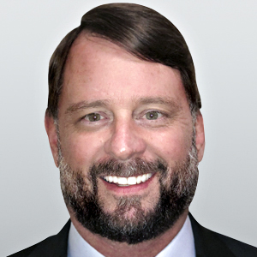](https://www.theepochtimes.com/author-jeff-carlson)

[Jeff Carlson](https://www.theepochtimes.com/author-jeff-carlson)

August 19, 2022 Updated: August 25, 2022

[biggersmaller](javascript:void(0))

Print

*News Analysis*

Following the [FBI](https://www.theepochtimes.com/t-fbi)’s raid of the residence of former President Donald Trump, there’s been much speculation about the Department of Justice’s ([DOJ](https://www.theepochtimes.com/t-doj)) motivation. Was it done to prevent Trump from running again in 2024, or was the raid related to documents and evidence surrounding the Jan. 6 commission?

While these factors may have had some bearing on the FBI’s raid, some entirely different, and potentially larger, factors may be at play.

It’s likely that the FBI’s raid was driven by intelligence community fears over information that was contained within those documents relating to the Russiagate hoax.

The DOJ’s coordinated FBI raid of Mar-a-Lago was likely related to the potential unsealing and public presentation of this information—particularly in relation to [Trump’s Racketeer Influenced and Corrupt Organizations Act (RICO) suit](https://storage.courtlistener.com/recap/gov.uscourts.flsd.610157/gov.uscourts.flsd.610157.1.0_8.pdf) against Hillary Clinton, the Democratic National Committee, and former FBI officials such as former Director James Comey, former Deputy Director Andrew McCabe, former agent Peter Strzok, and former FBI lawyer Lisa Page—and his amended RICO suit, which added more defendants.

As new information has come to light, we’ve gained increased confidence and feel even more strongly regarding this theory. The vast breadth and scope of the search warrant alone have bolstered this theory. But that’s far from being the only reason behind our belief.

An Aug. 17 [Newsweek](https://www.newsweek.com/fbi-sought-documents-trump-hoarded-years-including-about-russiagate-1734280) article included some remarkable statements from two sources within the Intelligence Community (IC).

One of these sources noted that “agents went into Trump’s residence on the pretext that they were seeking all government documents … but the true target was this private stash” of documents amassed by Trump, “which Justice Department officials feared Trump might weaponize.” The second source claimed that although the FBI supposedly “collected everything that rightfully belonged to the U.S. government,” the true target of the DOJ-led FBI raid was “these documents that Trump had been collecting since early in his administration.”

Both sources note that the “sought-after documents deal with a variety of intelligence matters of interest” to Trump—“including material that Trump apparently thought would exonerate him of any claims of Russian collusion in 2016 or any other election-related charges.” In other words, documents that Trump had collected and held within his possession proved the Russiagate hoax was exactly that: a hoax, which was led by officials from within our nation’s highest institutions—including, but not limited to, the FBI and the DOJ.

Although we’re generally not in the habit of giving much, if any, heed to sources within the IC, these particular revelations overlay with our own theory and the information we’ve come across. As we shall see from events in the timeline, Trump’s actions, and the documents he amassed over time, appear to have presented a very direct threat to the agencies that lie behind our government, prompting an institutional response that manifested itself in the FBI’s Aug. 8 raid of Mar-a-Lago.

In particular, the RICO suit brought by Trump in 2022 presented a potential vehicle for these documents to make their way into the public realm.

On Jan. 19, 2021, [then-President Trump declassified](https://trumpwhitehouse.archives.gov/presidential-actions/memorandum-declassification-certain-materials-related-fbis-crossfire-hurricane-investigation/) “a binder of materials related to the Federal Bureau of Investigation’s Crossfire Hurricane investigation” although he also accepted some “redactions proposed for continued classification by the FBI.”

Importantly, Trump also stated that “at my direction, the Attorney General has conducted an appropriate review to ensure that materials provided in the binder **may be** disclosed by the White House in accordance with applicable law.” **In other words, the DOJ was aware—and had at some point reviewed—all the documents contained in the binder that Trump declassified.** As we know, Attorney General Merrick Garland’s DOJ has [“failed to declassify](https://www.ronjohnson.senate.gov/services/files/22222FCF-C8F6-4CE5-967C-D0A2BFA7C6A8) a single page” of those documents.

Fast forward to mid-January of 2022. According to a [Feb. 7 statement](https://www.archives.gov/press/press-releases/2022/nr22-001) by the National Archives and Records Administration (NARA), the archives arranged for the transport of 15 boxes that contained presidential records from Mar-a-Lago, “following discussions with President Trump’s representatives in 2021.” Trump stated that the discussions were “collaborative and respectful” and said it was a “great honor” to work with the archives.

His representatives also told the agency they would continue to look for more presidential records. Shortly thereafter, on Feb. 14, NARA [claimed in a statement](https://www.archives.gov/press/press-releases/2022/nr22-001) that “some of the Trump presidential records received by the National Archives and Records Administration included paper records that had been torn up by former President Trump.”

The next day, Feb. 15, 2022, Sens. Chuck Grassley (R-Iowa) and Ron Johnson (R-Wis.) [sent a letter](https://www.ronjohnson.senate.gov/services/files/22222FCF-C8F6-4CE5-967C-D0A2BFA7C6A8) to Garland stating that the DOJ has so far refused to comply with the declassification order that Trump issued in January 2021. The letter noted that “the Justice Department has not only

1. failed to declassify a single page, the Department has
2. failed to identify for Congress records that it knows with certainty to be covered by the declassification directive.”

Grassley told Garland that the DOJ must “identify the records subject to the declassification order and, second, produce those records to Congress and the American people without improper redactions.”

Three days later, in [a letter sent by NARA archivist](https://www.archives.gov/files/foia/ferriero-response-to-02.09.2022-maloney-letter.02.18.2022.pdf) David Ferriero to the politicized House Oversight and Reform Committee, Ferriero stated that “NARA has identified items marked as classified national security information within the boxes.” Bear in mind that as president, Trump held ultimate authority on whether the documents were classified.

Also keep in mind the letter from Grassley just three days earlier, noting that the DOJ had thus far refused to comply with Trump’s declassification order. A week later, the House Oversight Committee [demanded](https://oversight.house.gov/news/press-releases/oversight-committee-expands-investigation-into-former-president-trump-s) that “NARA turn over additional information, including an inventory of the boxes recovered from Mar-a-Lago and information on any classified documents, as well as documents from the Trump Administration related to the former President’s destruction of records.”

[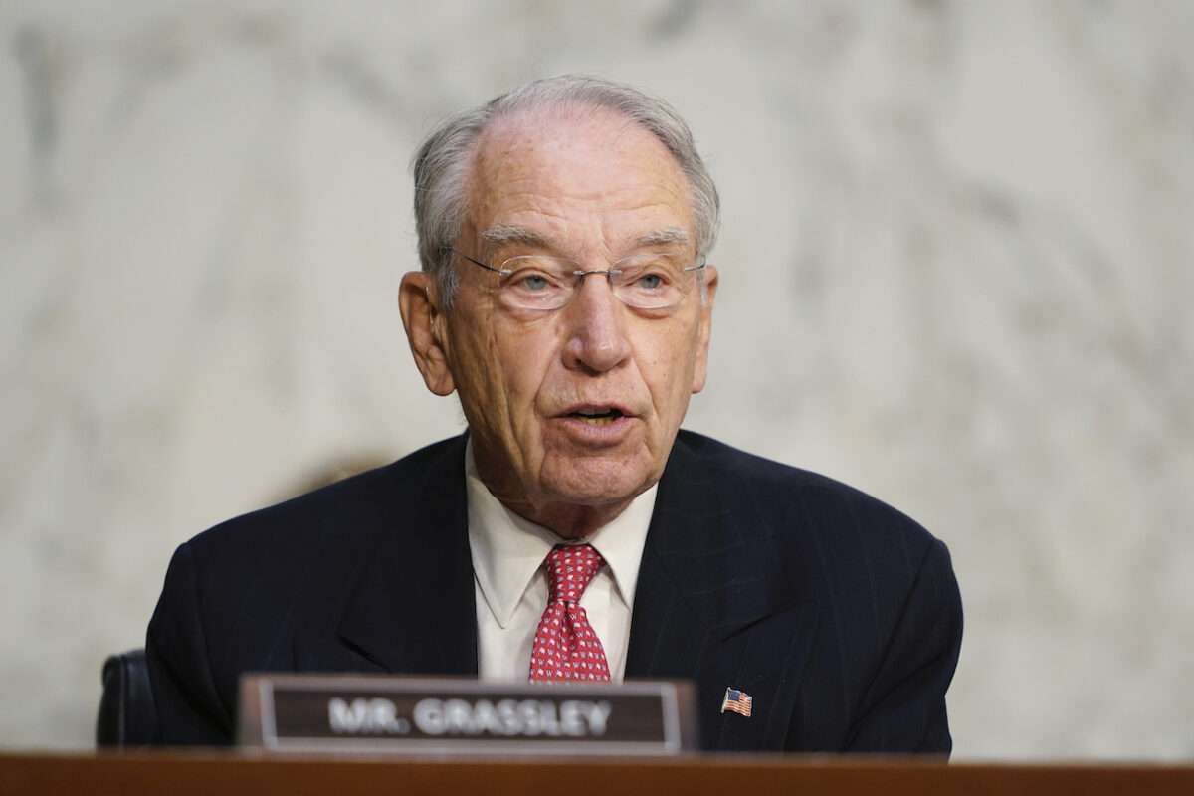](https://img.theepochtimes.com/assets/uploads/2021/02/05/chuck-grassley-1200x800.jpg)   
Sen. Charles Grassley (R-Iowa) speaks before the Senate Judiciary Committee on Capitol Hill in Washington, on Oct. 14, 2020. (Susan Walsh/AP Photo)

As this game was playing out, Trump was in the process of compiling his [original RICO suit](https://storage.courtlistener.com/recap/gov.uscourts.flsd.610157/gov.uscourts.flsd.610157.1.0_8.pdf).

Trump on March 24 formally filed his RICO suit, which stated that “the Defendants maliciously conspired to weave a false narrative” that Trump was “colluding with a hostile foreign sovereignty,” namely Russia. Trump’s lawsuit stated that **“the actions taken in furtherance of their scheme—falsifying evidence, deceiving law enforcement, and exploiting access to highly-sensitive data sources—are so outrageous, subversive and incendiary that even the events of Watergate pale in comparison.”**

For the next two months, things stayed relatively quiet. Then, on May 31, Grassley sent the [first of four letters](https://www.grassley.senate.gov/imo/media/doc/CEG%20to%20DOJ%20FBI%20(WFO).pdf) to Garland and FBI Director Christopher Wray.

Grassley leveled a very serious allegation, noting that “while serving in a highly sensitive role that includes threshold decision-making over which Federal public corruption matters are opened for investigation,” the assistant special agent in charge at the Washington Field Office, Timothy Thibault, violated federal regulations and Department guidelines designed to prevent political bias from infecting FBI matters.

Grassley told Wray and Garland that actions by Thibault undermine “both the FBI and DOJ because, at minimum, it creates the perception of unequal application of the law.”

On June 3, three days after Grassley’s letter to Wray, FBI agents went to Mar-a-Lago and inspected the storage facility and its containment of documents held by Trump. According [to reports](https://www.realclearinvestigations.com/articles/2022/08/18/fbi_unit_leading_mar-a-lago_probe_previously_led_russiagate_hoax_848582.html), Jay Bratt, the top counterintelligence official at the DOJ’s national security division, “personally inspected the storage facility while interacting with both Trump and one of his lawyers.”

Trump [reportedly “allowed](https://www.realclearinvestigations.com/articles/2022/08/18/fbi_unit_leading_mar-a-lago_probe_previously_led_russiagate_hoax_848582.html) the three FBI agents Bratt brought with him to open boxes in the storage room and look through them.”

These FBI agents reportedly left with some of the documents. Bratt also requested “increased security at the facility and asked to see surveillance footage from the security cameras.” A lawyer for Trump complied with the requests.

[Epoch Times Photo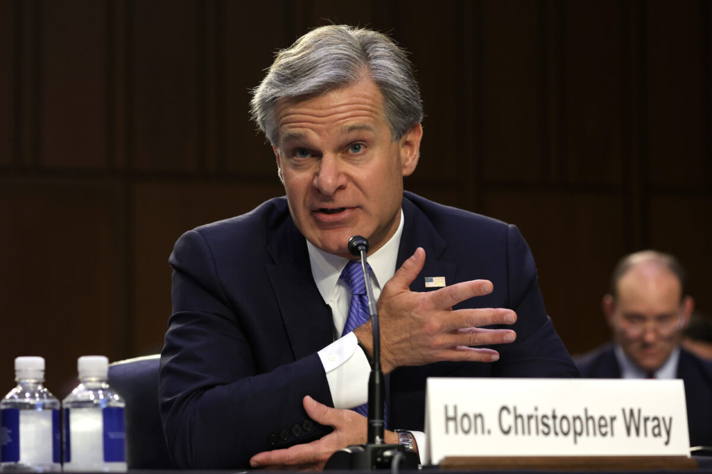](https://img.theepochtimes.com/assets/uploads/2022/08/11/Christopher-Wray-1200x800.jpg)   
FBI Director Christopher Wray testifies during a hearing before the Senate Judiciary Committee on Capitol Hill in Washington on Aug. 4, 2022. (Alex Wong/Getty Images)

This sequence is important as it demonstrates that the DOJ and FBI either knew, or had a very good idea of, what they were seizing in their Aug. 8 raid. It also makes some of the leaks made to the media, which claimed that Trump was endangering national security, seem somewhat ridiculous in hindsight.

If the FBI was aware of Trump’s possession of such material, or could accuse him of endangering national security, they would have done so on the spot during the June 3 visit to Mar-a-Lago. At a minimum, the FBI could have responded with a warrant in the days immediately following the visit. Instead, several months went by before the DOJ and FBI elected to raid Mar-a-Lago.

As we shall see, there were some significant events that followed the FBI’s June 3 visit.

The first of these events took place on June 21, when Trump filed an [amended RICO suit](https://storage.courtlistener.com/recap/gov.uscourts.flsd.610157/gov.uscourts.flsd.610157.177.0_3.pdf) against Clinton and a large number of other DNC-related individuals who were involved in the Russiagate hoax.

The new suit, at 193 pages in length, was significantly more robust and detailed than Trump’s original March 24 RICO suit, and included additional defendants. On the same day, Kash Patel, a former Trump administration official who’s worked diligently to get Trump’s declassified documents released, announced on a podcast that he was officially a representative for Trump at the National Archives.

Patel said it was his intention to “identify every single document that they blocked from being declassified,”  and stated that he “would start putting that information out next week.”

The following day, June 22, Magistrate Bruce Reinhart suddenly recused himself from Trump’s suit against Clinton and Company. Just 44 days later, after his unexpected recusal from Trump’s RICO case against Clinton, Reinhart personally signed the search warrant to raid Mar-a-Lago.

On July 14, there was another surprise development in Trump’s RICO case against Clinton and Company. [In a motion](https://storage.courtlistener.com/recap/gov.uscourts.flsd.610157/gov.uscourts.flsd.610157.224.0_1.pdf) put forth by [Juan Gonzalez](https://www.justice.gov/usao-sdfl/meet-us-attorney), the U.S. Attorney for the Southern District of Florida, it was requested that “the United States shall be substituted as the party defendant.” In other words, the DOJ wanted to “substitute itself as the defendant for James Comey, Andrew McCabe, Peter Strzok, Lisa Page, and Kevin Clinesmith.”

The motion claimed that Trump’s RICO claims were “based upon conduct within the scope of these former FBI employees’ employment with the government,” and stated that “the United States is the sole and exclusive defendant for those claims.” The [motion also requested](https://storage.courtlistener.com/recap/gov.uscourts.flsd.610157/gov.uscourts.flsd.610157.224.0_1.pdf) that if the substitution was accepted, “the Court should dismiss the United States for lack of subject matter jurisdiction.”

The motion noted that since Trump hadn’t exhausted his administrative remedies, the Court lacked subject matter jurisdiction and should therefore dismiss the case after substituting the United States as the defendant. The DOJ was maneuvering to place itself into Trump’s RICO suit—and then have Trump’s suit dismissed. This tactic was actually successful—at least in part.

[Epoch Times Photo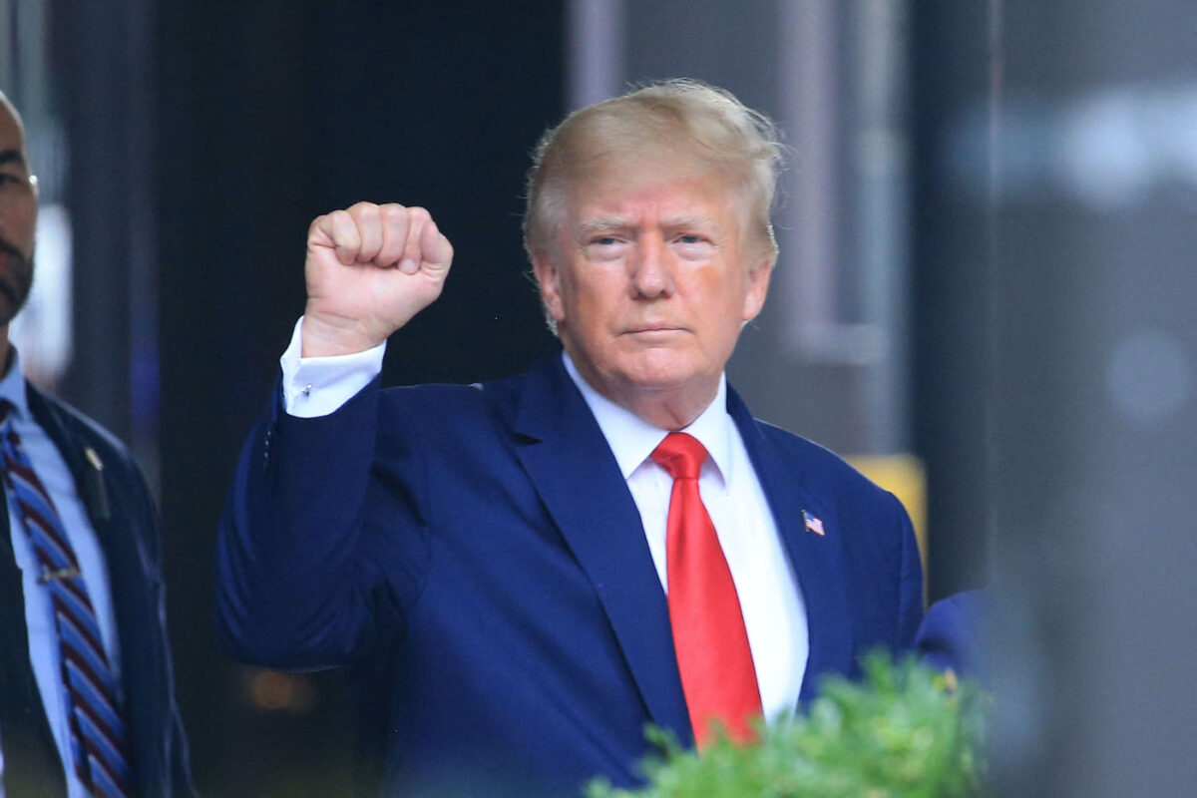](https://img.theepochtimes.com/assets/uploads/2022/08/17/GettyImages-1242419185-1200x800.jpg) Former U.S. President Donald Trump raises his fist while walking to a vehicle outside of Trump Tower in New York City on Aug. 10, 2022. (Stringer/AFP via Getty Images)

On July 22, trial Judge Donald Middlebrooks [granted the motion](https://storage.courtlistener.com/recap/gov.uscourts.flsd.610157/gov.uscourts.flsd.610157.234.0_1.pdf) to substitute, replacing Comey, McCabe, Strzok, Page, and Clinesmith with the United States as defendant.

Middlebrooks cited the Westfall Act, which “accords federal employees absolute immunity from common-law tort claims arising out of acts they undertake in the course of their official duties.” He deferred ruling on dismissal and noted that Trump was entitled to “litigate the question of whether the employees were acting within the scope of their employment when the challenged conduct occurred.”

The DOJ had successfully inserted itself into Trump’s RICO suit, bringing with it all the legal weight and firepower held by the U.S. government. It’s worth noting that the information previously declassified by Trump is directly relevant to his suit. Meanwhile, the DOJ, which has stalled its release, is now in the official legal position of fighting against its release in court.

Amid this maneuvering by the DOJ, Grassley sent a [second letter](https://www.grassley.senate.gov/imo/media/doc/grassley_to_justice_dept_fbi_-_political_bias.pdf) to Wray and Garland on July 18. Grassley told both men that allegations by a number of “highly credible whistleblowers” have prompted “fundamental questions about whether the Justice Department and FBI are properly fulfilling their combined law enforcement mission with impartiality and without fraud, abuse, and gross mismanagement.”

One week later, on July 25, Grassley issued a [statement](https://www.grassley.senate.gov/news/news-releases/whistleblowers-reports-reveal-double-standard-in-pursuit-of-politically-charged-investigations-by-senior-fbi-doj-officials) containing [letters](https://www.grassley.senate.gov/imo/media/doc/grassley_to_justice_deptfbipoliticalbiasfollowup.pdf) to Wray and Garland, stating that information Grassley had received “involves concerns about the FBI’s receipt and use of derogatory information relating to Hunter Biden, and the FBI’s false portrayal of acquired evidence as disinformation,” referring to the son of President Joe Biden. Grassley said that “if these allegations are true and accurate, the Justice Department and FBI are—and have been—institutionally corrupted to their very core.”

[FBI affidavit hearing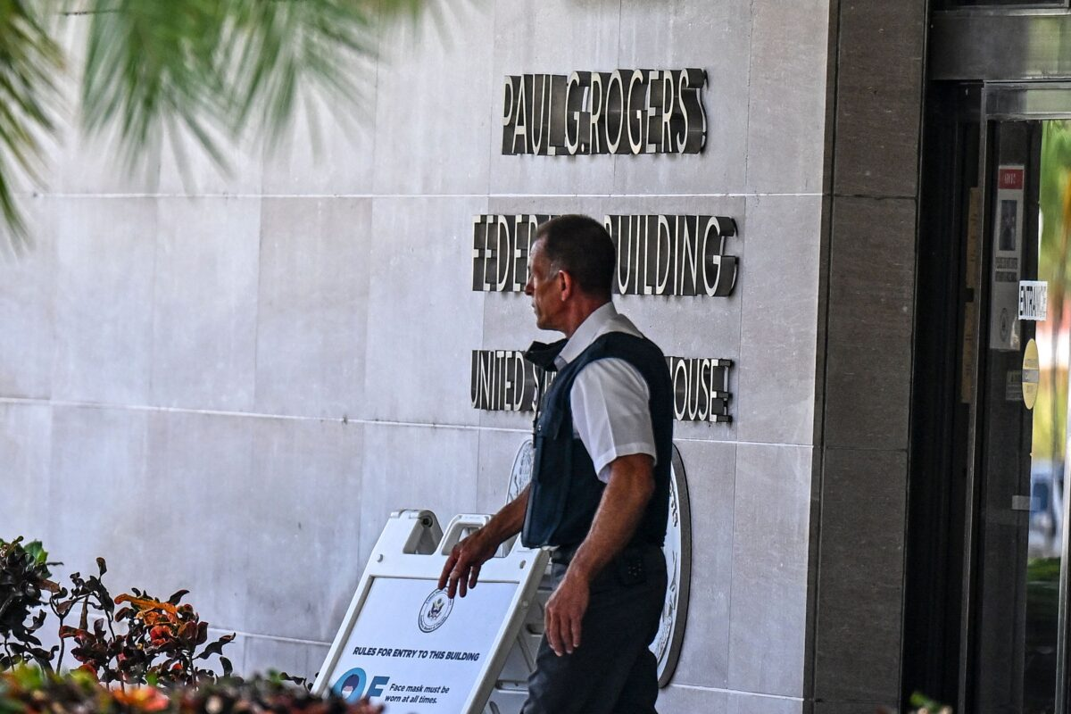](https://img.theepochtimes.com/assets/uploads/2022/08/19/Court-GettyImages-1242577895-1200x800.jpg) Security officers guard the entrance to the Paul G. Rogers Federal Building and Courthouse as the court holds a hearing to determine if the affidavit used by the FBI as justification for the search of Trump’s Mar-a-Lago estate should be unsealed, in West Palm Beach, Fla., on Aug. 18, 2022. (Chandan Khanna/AFP via Getty Images)

Shortly thereafter, on Aug. 4, Trump [filed in opposition](https://storage.courtlistener.com/recap/gov.uscourts.flsd.610157/gov.uscourts.flsd.610157.238.0.pdf) to Middlebrooks’s ruling to substitute the United States—in other words, the DOJ—for Comey, McCabe, Strzok, Page, and Clinesmith. Trump also [filed in opposition](https://storage.courtlistener.com/recap/gov.uscourts.flsd.610157/gov.uscourts.flsd.610157.237.0_2.pdf) to Clinton’s earlier motion to dismiss the entirety of the RICO complaint against her and her fellow defendants, which included the DNC, and familiar names such as lawyers Marc Elias and Michael Sussmann, Rep. Adam Schiff (D-Calif.), former journalist Glenn Simpson, former DOJ official Bruce Ohr, and his wife, Nellie Ohr.

The next day, Aug. 5, Reinhart signed the FBI search warrant for Trump’s Mar-a-Lago property. Garland later stated in his [press conference](https://www.youtube.com/watch?v=S-W2-8fgp1o) that he “personally approved the decision to seek a search warrant.” Trump’s Mar-a-Lago property was raided three days later, on Aug. 8.

We know the [search warrant](https://storage.courtlistener.com/recap/gov.uscourts.flsd.617854/gov.uscourts.flsd.617854.17.0_7.pdf) wasn’t “focused,” as Garland had stated. In fact, it was extremely broad and included any presidential records from Trump’s entire term in office.

It’s also worth repeating that the DOJ knew what documents Trump was holding after its June 3 visit. The DOJ also knew everything that lay within the binder that Trump had ordered to be declassified, since Trump had sent the binder to the department for declassification processing.

If the DOJ had evidence of specific crimes they wouldn’t have used such a broad and vague warrant. It was a targeted fishing expedition—designed to capture any and all information relating to the Russiagate hoax—at the exact time that the DOJ is defending its actions taken in the Russiagate hoax in court against Trump’s RICO case.

On Aug. 17, Grassley sent a fourth letter to Wray, stating that “a deeply rooted political infection has spread to investigative activity into former President Trump and Hunter Biden.” To date, the FBI has failed to address the concerns raised by Grassley and has failed to produce the records he requested.

*Watch the*[*full episode*](https://www.theepochtimes.com/c-truth-over-news)*on EpochTV’s “Truth Over News” next week.*